|  |
| --- |
| 01818233026.jpg |

**GAZI MOHAMMED ABUL HOSSAIN**

**Present Address:**

C/O- Bhuyan Gazi Bari

1 No South Pahartali

Fathehabad, Hathazari

Chittagong.

Mobile No: +8801818233026

Email : [gazisohelbd@gmail.com](mailto:gazisohelbd@gmail.com)

**Permanent Address:**  DO

**COMPUTER SKILLS:**

* Computer fundamentals, Dos, Windows, Ms Word, Ms Excel, Ms Power Point etc. ( National Youth Training Center )
* Master Network Engineering Program (MNEP) New Horizons, Chittagong.

**NETWORK CERTIFICAT:**

* New Horizon Foundation (MS Office Application 2007 + 2013).
* A+ Certification. (**Computer Fundamentals**)
* Configuring and Troubleshooting Microsoft Windows Server 2008 Active Directory Domain Service (ADDS).
* Configuring and Troubleshooting a Microsoft Windows Server 2008 Network Infrastructure.
* Planning and Administering Microsoft Windows Server 2008.
* Configuring and Troubleshooting Internet Information Services (IIS) in Windows Server 2008.
* Microsoft Exchange Server 2010 Configuring.
* Cisco Certified Network Associate **(CCNA).**
* CompTIA : **Linux+**

**Participation**

Concept of Routing Protocol ( **RIP,IGRP,EIGRP,OSPE**) & Configuring **EIGRP** and **OSPF** Summary Routes. ( [www.technews365.info](http://www.technews365.info) )

**OTHER SKILLS:**  Trainer at Explore IT Solution

(Fatehabad, Hathazari, ctg)

**Education:**

|  |  |  |  |  |
| --- | --- | --- | --- | --- |
| **Name of Exam** | **Group/Subject** | **Passing Year** | **Result** | **Board/University** |
| S.S.C | Business study | 2009 | 4.19 | Chittagong |
| H.S.C | Business study | 2012 | 2.90 | Chittagong |
| B.B.S | Business study | 2015 | 2nd Class | National University |
| M.S.S | Economic | 2017 | Part (I) | National University |

**Languages:**

English : Reading, Writing and Speaking

Bengali : Reading, Writing and Speaking

**Interests and Hobbies :**

2. Reading Books.

**Profile:**

I believe in hard work, integrity, perseverance and dedication towards the work on my hand advancement through exploration to newly acquired knowledge in future.

**Personal Particulars :**

* Father’s name : Gazi Mohammed Nur Hossain
* Mother’s name : Laila Begum
* Nationality : Bangladeshi
* Date of birth : 18 November 1992
* Place of birth : Chittagong
* Religion : Islam
* Sex : Male
* Marital status : Single

**Declaration:**

* I do hereby declare that particulars provided in the resume are true to best of knowledge and belief.

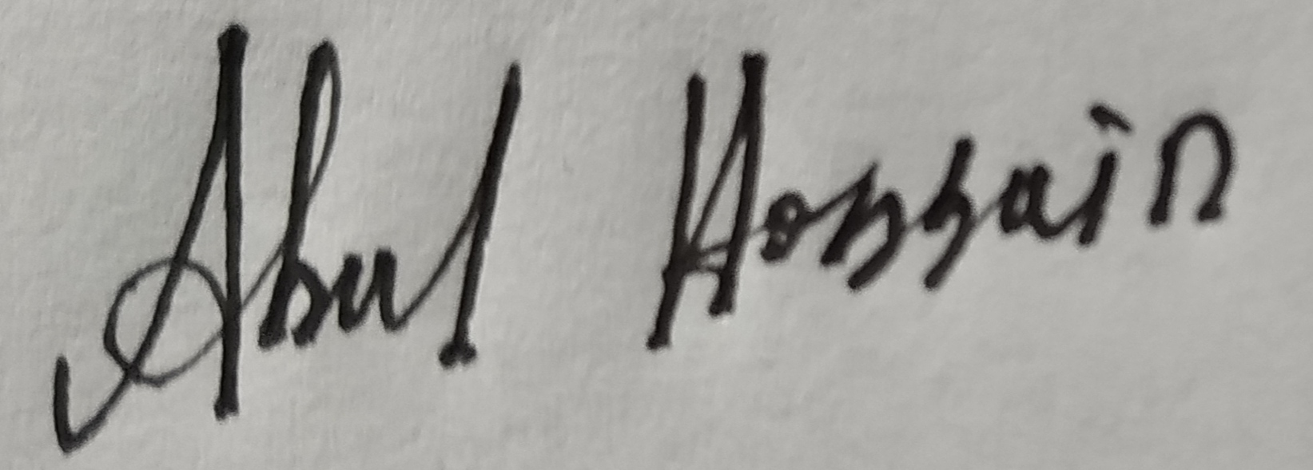

(Signature)